**Hands-on 1: Create a Spring Web Project using Maven**

**1. Create the Project using Spring Initializr**

1. Go to: <https://start.spring.io>
2. Fill the form:
   * **Group**: com.cognizant
   * **Artifact**: spring-learn
   * **Name**: spring-learn
   * **Dependencies**:
     + Spring Boot DevTools
     + Spring Web
3. Click **GENERATE** to download the zip.
4. Extract it to Eclipse workspace or a convenient folder.

**2. Run the Application**

1. Open SpringLearnApplication.java
2. Add a simple line inside main():

System.out.println("Spring Boot Application Started");

**Output:**

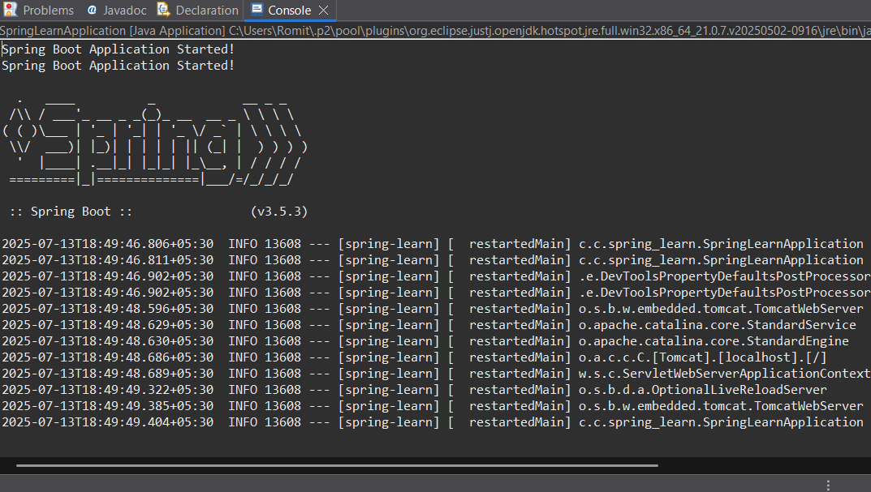

**Hands-on 2: Spring Core – Load SimpleDateFormat from Spring Configuration XML**

**Goal:**

Avoid creating SimpleDateFormat in multiple places by defining it as a bean in a Spring XML config file and retrieving it in your app.

**1. Create XML Config File**

1. In Eclipse, go to src/main/resources
2. Right-click → **New > File** → Name it: date-format.xml

<?xml version="1.0" encoding="UTF-8"?>

<beans xmlns="http://www.springframework.org/schema/beans"

xmlns:xsi="http://www.w3.org/2001/XMLSchema-instance"

xsi:schemaLocation="

http://www.springframework.org/schema/beans

https://www.springframework.org/schema/beans/spring-beans.xsd">

<bean id="dateFormat" class="java.text.SimpleDateFormat">

<constructor-arg value="dd/MM/yyyy" />

</bean>

</beans>

2. **Update SpringLearnApplication.java**

package com.cognizant.spring_learn;

import org.springframework.boot.SpringApplication;

import org.springframework.boot.autoconfigure.SpringBootApplication;

import java.text.SimpleDateFormat;

import java.util.Date;

import org.springframework.context.ApplicationContext;

import org.springframework.context.support.ClassPathXmlApplicationContext;

*@SpringBootApplication*

public class SpringLearnApplication {

public static void main(String[] args) {

SpringApplication.*run*(SpringLearnApplication.class, args);

*displayDate*();

}

public static void displayDate() {

ApplicationContext context = new ClassPathXmlApplicationContext("date-format.xml");

SimpleDateFormat format = context.getBean("dateFormat", SimpleDateFormat.class);

try {

Date date = format.parse("13/07/2025");

System.***out***.println("Parsed Date: " + date);

} catch (Exception e) {

e.printStackTrace();

}

}

}

**Output:**

